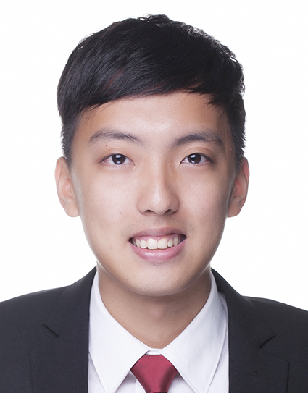Aiden Gan Tian Wei

Block 864 Tampines St 83 #05-438 Singapore 520864

+(65)91253870

aidengantianwei@gmail.com

**Education**

**Nanyang Business School, Nanyang Technological University** **Aug 2012 – May 2015**

**Bachelor of Business**, Specializing in Banking & Finance

Graduated in May 2015

**Tampines Junior College, GCE A Level Certificate** **Dec 2009**

**Work Experience**

**INTL FCStone, Global Payment Operations**

* Handle foreign exchange trades and ensure timely and smooth settlement
* Investigate post trade issues and liaise with external parties to solve the problem
* Involved in projects to improve settlement processes and daily operations

**UBS AG, Clearing and Settlement May 2015 – Aug 2015**

* Assist in settling trades done by UBS WM which include bonds, equity and structured products
* Answering any queries or investigating any discrepancy between trades
* Communicating with internal and external parties to ensure smooth settling of trade

**Partner's Group, Fund Administration (Internship) Oct 2014 – Mar 2015**

* Ensure that quarterly and annual report are correctly reported
* Communicate with other private equity fund manager for feedbacks or requests
* Calculate relevant and useful ratio for evaluation of fund

**Yuuzoo Corporation, Finance (Internship) May 2014 – Jul 2014**

* Help with updating of daily accounts and balancing end of month figures
* Update and checks files and documents needed for IPO

**Singtel, Singapore, Administrative Assistant Mar 2012– Jul 2012**

* Worked closely with management to provide quality deliverables to clients
* Analysed and processed data for the department and external organisation.

**Singapore Armed Force, Signal Specialist Apr 2010- Feb 2012**

* Displayed leadership and ability to work and communicate with others
* Assigned the responsibility of leading a detachment

**CCA/Activities**

**Softball for Hall, Vice Captain**

* Represented NTU Hall 16 in Inter Hall Games
* Trained and lead my team of 15 members effectively

**Tampines Junior College Soccer, Member**

* Learnt to work as a team and thrived in a competitive environment

**National Youth Achievement Award – Silver**

* Fulfilled the strict requirements for 4 sections which is Service, Adventure, Skills, Physical Recreational

**Others**

**Written And Spoken Languages**: English and Chinese

**IT Skills**: Proficient in MS Office (Excel, PowerPoint and Word), Basic skills in Thomas Reuter Eikon

**Language Proficiency**: English (Advanced), Mandarin (Chinese) (Advanced)

**Interest:** Outdoors Sports, Biking, Cooking